**MONITORING VISIT REPORT**

**Indian Institute of Health and Family Welfare (IIHFW)**

**Hyderabad**

**(Telangana)**

**Training on RKSK**

**(18th & 20th August 2015)**

**Submitted By:**

**Mr. Upendra Singh**

**Consultant (RO)**

**NHM/RCH-II**



**NATIONAL INSTITUTE OF HEALTH & FAMILY WELFARE**

Baba Gangnath Marg, Munirka, New Delhi - 110067

**Introduction:**

At 253 million, India has the largest share of the adolescent population in the world. With a view to address the health and development needs of this age group which is 21percent of India’s population. RKSK has been developed to strengthen the adolescent component of the RMNCH+A strategy which, as we are all aware, is one of the weakest and a sub-critical programme area. Whilst core programming principles for RKSK are health promotion and a community based approach expanded scope of the programme includes nutrition, sexual & reproductive health, injuries and violence (including gender based violence), non-communicable diseases, mental health and substance misuse.

**Objectives of training programme:**

The overall objective is to orient ANMs/LHVs to the special needs and concerns of adolescent boys and girls and to design appropriate approaches to address these. This will strengthen the abilities of health-service providers to be able to respond to adolescents needs more effectively and with greater sensitivity. It is expected that this Orientation Programme will significantly contribute to building capacity on adolescent health and development issues.

**Expected Outcomes:**

It is expected that ANMs/LHVs who participate in this Programme will:

• Be more knowledgeable and aware about the characteristics of adolescence and the various issues and concerns of adolescent health and development;

• Be more sensitive to adolescent needs and concerns;

• Be able to provide “adolescent-friendly” health services that respond to their needs and are sensitive to their preferences;

• Be able to refer them to doctors in a timely manner.

• Design a personal plan of action indicating the changes they will make in their personal and professional lives and their surroundings.

**The orientation training is not intended to equip participants with specific clinical skills in adolescent health care.**

**Methodology**

The teaching and learning methods used throughout the Orientation Programme are participatory and appropriate to working with adults who always bring a wealth of personal experience to any learning event. It is recognized that the main group of intended participants already have some experience of working with adolescents and adolescent health issues. A participatory approach enables the individual to draw on her own experience and learn in an active way. It also enables a more equal relationship between participants and facilitators than is possible in more conventional trainer-learner or teacher student approaches.

The Programme uses a range of methods and approaches in small groups and role play sessions.

* Flipchart presentation
* Self reading of module
* Case studies
* Group exercise with problem cards
* Brainstorming and Group discussion
* Role play

***RKSK training package included the following:-***

Set of 12 modules for ANM/LHV for 5 days training is as follows:

Day-1

Module I Introductory module

Module II Adolescent Growth and Development and its implication on health

Module III Dealing with the Adolescent Client

Day-2

Module IV Adolescent-Friendly Health Services

Module V Sexual and Reproductive Health Concerns of Adolescent Boys & Girls

Day-3

Module VI Nutritional needs of Adolescents and Anaemia

Module VII Pregnancy & Unsafe Abortions in Adolescents

Day-4

Module VIII Contraception for Adolescents

Module IX RTIs, STIs and HIV/AIDS in Adolescents

Module X NCDs, Injuries, Aggression and Violence

Day-5

Module XI Mental Health in Adolescents

Module XII Concluding Module

**DETAILS OF TRAINING MONITORING VISIT:**

The visit was undertaken to monitor the above said **RKSK training conducted at IIHFW, Hyderabad** to assess the quality of training rendered and to procure the data pertaining to the training.

* **Institute/facility where training conducted:** IIHFW, Hyderabad
* **Dates and duration of training course:** 18th August – 22nd August, 2015, for 5 days
* **Dates on which training monitored:** 18th to 20th August, 2015

**Training days & session observed:**

1st to 3rd day of RKSK training observed of total 5 days training.

***Day -1 (18 Aug.):*** On 1st day total 11 sessions held of first 3 modules. First 8 sessions held before lunch and remaining 3 sessions held after the lunch.

* First of all introductory session held, pretest given by participants.
* Physical, emotional and sexual development and changes in adolescents.
* Dealing with adolescent’s person, counseling and role play for multi stage adolescent problems, counseling session for problem solving.

***Day -2 (19 Aug.):*** On 2nd day total 7 sessions held of 4th & 5th module. First 4 sessions held before lunch and remaining 3 sessions held after the lunch.

* Review of first day sessions
* Adolescent friendly health services, flip chart presentation by group discussion
* Covering the services 6 ‘A’, community level assistance
* Sexual and reproductive health of adolescent boys and girls
* Play role on six issues and discussion with problem cards

***Day -3 (20 Aug.):*** On 3rd day total 7 sessions held of 6th & 7th module. First 4 sessions held before lunch and remaining 3 sessions held after the lunch.

* Review of first and second day sessions
* Discussion and role play on nutritional needs of adolescents and anaemia
* School health services for anaemia and video presentation on the topics
* Discussion and role play on pregnancy & unsafe abortions in adolescents

**Name of persons interacted with:**

1. Sh. S. Gopikanth Reddy, Secretary, IIHFW
2. Dr. V. Venkat Rao, Programme Officer, RKSK, Telangana
3. Dr. A. Saibaba, Professor, IIHFW
4. Dr. V. Uma Devi, Coordinator cum Trainer, RKSK, IIHFW
5. Dr. Shobha Rani, PODTT, Hyderabad (Trainer-RKSK)
6. Dr. Vijaya Kumar, (Trainer- RKSK), Paediatrician, Govt Maternity Hospital, Warangal
7. Faculty Members of IIHFW, Hyderabad
8. Participants of the RKSK training (MPHA-F /ANMs)
9. Staff and Trainers & Trainees of PPIUCD training at RHFWTC, Kothi, Hyderabad

**I Salient Observations:**

* **Training Details:**
* Batch Size – 35
* Number of Trainers - 3
* Duration of training – 5 days
* Trainees/Participants – 26 ANMs
* Place – IIHFW, Hyderabad
* Dates of trainings: 18th August – 22nd August, 2015, for 5 days
* Dates on which training monitored: 18th to 20th August, 2015
* Total 30 persons nominated for the said training but 26 only attended the training course.
* All the trainees had received the training module and material in beginning of the training.
* The RKSK training conducted as per latest available guidelines of MoHFW and they used latest version of training module for ANMs/LHVs.
* **Quality check of the training:**

**1. Training Site**-

* The training site was well equipped and well facilitated to conduct the training.
* There was adequate space of seating and conducting the training, the RKSK training conducted in a large size conference hall equipped with round table, chairs, A.Cs, projector with screen, stand for flipchart presentation, white board etc. The hostel facilities were available at the training site that was adequate and well maintained.

**2. Trainers –**

* There were three TOT trained trainers. They had 14 years of average experience in service.
* The ratio of the trainers and the trainees was 1: 8.6.
* Participants were well received and understanding well from the facilitators.
* Trainers using the required knowledge and experience to get improved adult learning.

**3. Trainees-**

* Expected batch size is 35 but total number of trainees was 26. Thus, the required batch size could not be completed.
* Trainees were selected prioritizing the UPHC of Hyderabad district to provide the improved adolescent health services at the designated PHCs and centers where AFHC services are being provided.
* Participants responding well to the trainers and active participatory approach seen at the level of learners and trainers.

**4. Availability of Training Materials and Training Aids -**

* The teaching aids available are flip chart/ activity chart, short video clips, LCD projector, Mike and speakers, white screen etc.
* Training Module and material was provided to the participants in local (Telgu) language.
* Short videos clips related to the adolescent issues were shown during the sessions to increase the required knowledge, interest and participation.

**5. Conduction of Training –**

Training was conducted as per the GoI guidelines and prescribed modules were distributed to all the trainees before inception of the training. The sessions were held on time and the contents covered well as per the session schedule.

**II Promotive /good Practices:**

1. Overall good infrastructural arrangements were done for the trainees at the training site (IIHFW, Hyderabad). There was sufficient space at lecture/conference hall. Lecture theatre was well ventilated and equipped with LCD projector, White board, table, chair, AC, Fan etc.
2. Objective of training with deliverables were well explained to the participants before commencement of theoretical and clinical sessions of the training.
3. There was a two-way communication between the trainers & trainees. Clarification of doubts was handled by the trainers well.
4. Videos shown was in Hindi/Telgu language, however trainees communicated in local language also as the requirement felt by trainers/trainees.
5. The training site found to use its resources maximally and the trainers had significant training experience of around 14 years in average.
6. The training site had ample resources to provide two parallel trainings at a time with all functional facilities for the trainees.
7. IIHFW had well build infrastructure for the trainings.
8. All the participants nominated for the said training was chosen from the functional UPHCs from all areas of urban Hyderabad to cater the needs of the beneficiaries through RKSK training.
9. The trainers had good rapport with all the participants of the training and were interacting in Telgu language most of time to have better grasp and delivery of training to participating ANMs.
10. The participants of the training were keen towards the up gradation of their skills in counseling and knowledge towards management of issues pertaining to adolescents.

**III Drawbacks & Weaknesses:**

* The standard batch size as per GoI guideline is 35 but there were less number of trainees attended the training, i.e. 26.
* The pre-test score not taken in to account during the training.
* Trainers assigned for the training were not equally taking the task of training, the one female trainer were dominating the whole training. However, she had excellent command and acceptance among trainees, other one male and female had least role to play.
* No other specific drawback and weakness found in whole training.

**IV: Possible recommendations and solutions of drawbacks & weaknesses:**

1. Field visit to nearby AFHC or slum school may be included in RKSK training to have some exposure of actual clients and targeted beneficiaries with factual problems.
2. In view of the tendency to attend less number of trainees then their nomination; the trainees may be nominated more than the required batch size to compensate the absentees. It will maximize the resource utilization and will be more cost effective.
3. The pre-test score shall be taken in to account for having improved and focused trainee centered training in which the knowledge is weak, can be taken more deliberately.
4. The trainers of the training shall interact with trainees more or less equally; however the expertness in an area specific may be a case exception.
5. Training duration may be reduced to 3 to 4 days who already undergone the ARSH training, as it felt repetition by the trainees, except the newly inclusions i.e. NCDs, Mental health and aggressive behavior.
6. Follow-up post training monitoring visits of the trained personnel should be taken in a periodic manner to ensure the performance of trained personnel in the particular thematic area for which he/she received the training.

**Checklist for Monitoring the Quality of RKSK Training, IIHFW, Hyderabad**

**1. General Information**

1. Name of Institute where training is conducted: __________ **IIHFW, Hyderabad** ______
2. Dates of visit: _______________**18th to 20th August 2015**________________________
3. Name of the district and state visited: _________**Hyderabad, Telangana** _________
4. Name, Designation & Organization of the person visiting ____**Upendra Singh , Consultant (RO)/ RCH-II/NIHFW**______
5. Name and type of session observed: ____**Total 25** **Session observed on 18th to 20th August 2015____**
6. Dates of present training course: ________**18th to 22nd August 2015**_______________
7. Number and contact details (Name, Category, Place of Posting & Contact Details) of Participants (Procure a copy): _______**26 Participants** _____

**2. Trainees**

1. Whether the proper number (as per specified size of the batch) of trainees have come to attend the training? (No. of person nominated: ____**30**___, No. of person attending the training: ____**26**___) **No**
2. Do they all have the training modules and guidelines? **Yes**
3. Are these training modules as per the latest MOHFW guidelines? *(Ask about the module version used and check it with the latest version available)* **Yes**
4. Have they attended the same training earlier? If yes, when? ___**No, but many of them undergone ARSH training**_____________
5. Are these trainees posted or to be posted where the services regarding this training could be utilized? **Yes**
6. Whether the Training being conducted as per training calendar received from NRHM/SIHFW? **Yes**
7. Whether the training site accredited as training venue? **Yes**
8. Whether the day to day schedule of the training programme has been distributed to all participants? *(Collect a copy of day to day programme Schedule)* **Yes**

**3. Training Site**

1. Is the sitting arrangement and required infrastructure sufficient enough for the training?  **Yes**
2. Is the training residential? **Yes**
3. Is drinking water facility available? **Yes**
4. Training venue equipped with electricity and back-up? **Yes**
5. Whether the food/mess facility available during training? **Yes**
6. Are the group arrangements and demonstration places identified among the participants? **Yes**
7. Whether washroom/toilet facility available? **Yes**

**4. Trainers & Trainees**

1. Is the number of trained trainers available adequate for training? **Yes**

**List of Trainers:**

|  |  |  |  |  |  |
| --- | --- | --- | --- | --- | --- |
| **S. No.** | **Name of Trainer** | **Designation** | **Place of Posting** | **Trained in year** | **Mob. No.** |
| 1 | Dr. Shobha Rani | PODTT | DTT, Hyderabad | June,15 | 9848259190 |
| 2 | Dr. Vijay Kumar | Pediatrician | UPHC, Tara Mai | June,15 | 8096519000 |
| 3 | Dr. V. Umadevi | Assoc. Prof. & RKSK state training coordinator | IIHFW, Hyderabad | Jan., 15 | 9701375279 |

**reporList of Trainees:**

|  |  |  |  |  |
| --- | --- | --- | --- | --- |
| **S. No.** | **Name of Trainees** | **Designation** | **Place of Posting** | **Mob. No.** |
|  | Ms. A. Rajya Lakshmi | MPHA (F) | UPHC, Shoukath Nagar | 7097805127 |
|  | Ms. A. Santhosh Kumari | MPHA (F) | UPHC, Jambagh Park | 8790727771 |
|  | Ms. B. Usha Shree | MPHA (F) | UPHC, Uppuguda | 9959495154 |
|  | Ms. C. Kavitha | MPHA (F) | UPHC, Nampally | 9603874952 |
|  | Ms. D. Lavanya | MPHA (F) | UPHC, Khairatabad | 8790750529 |
|  | Ms. E. Shoba Rani | MPHA (F) | UPHC, Jubileehills | 9390306998 |
|  | Ms. G. Nirmala | MPHA (F) | UPHC, Shalivahana Nagar | 8985754255 |
|  | Ms. G. Renuka | MPHA (F) | UPHC, Bagh Amberpet | 9676363205 |
|  | Ms. I. Jayalakshmi | MPHA (F) | UPHC, Esamia Bazar | 9908440938 |
|  | Ms. K. Nagalakshmi | MPHA (F) | UPHC, Charminar | 7416802885 |
|  | Ms. M. Esther Rani | MPHA (F) | UPHC, Bholakpur | 7842888947 |
|  | Ms. M. Sanjeeva | MPHA (F) | UPHC, Maharajgunj | 9010932043 |
|  | Ms. M. Vasantha Kumari | MPHA (F) | UPHC, Nayapool | 9247374417 |
|  | Ms. P. Prema Latha | MPHA (F) | UPHC, Sri Ram Nagar | 9701225325 |
|  | Ms. P. Sharadha | MPHA (F) | UPHC, Boggulakunta | 9290637273 |
|  | Ms. R. Bharathi | MPHA (F) | UPHC, Yakatpura-I | 9949584328 |
|  | Ms. R. Laxmi | MPHA (F) | UPHC, Teegal kunta | 9848590277 |
|  | Ms. R. Saroja | MPHA (F) | UPHC, Shanthi Nagar | 8977423771 |
|  | Ms. S. Esther Rani | MPHA (F) | UPHC, Syed Nagar | 9618122253 |
|  | Ms. S. Maheshwari | MPHA (F) | UPHC, Daruelshifa | 9290178411 |
|  | Ms. S. Tirumala | MPHA (F) | UPHC, Balagunj | 9177142695 |
|  | Ms. Sajida Begum | MPHA (F) | UPHC, Aghapura | 9032152315 |
|  | Ms. Y. Chandrakala | MPHA (F) | UPHC, Andhra Mahila Sabha | 9676205304 |
|  | Ms. K. Anitha | MPHA (F) | UPHC, Ameerpet | 9705922134 |
|  | Ms. R. Manemma | MPHA (F) | UPHC, Panjagutta | 9248301056 |
|  | Ms. G. Vidyapreethi | MPHA (F) | UPHC, Addagutta | 7386868405 |

1. Have they practiced training skill under supervision of master trainers during ToT? **Yes**
2. Whether registration of the participants for each batch done? **Yes**
3. Whether proper record of the training including the following being maintained: *(Tick the information recorded and ask to show, if available.)*
   1. No. of batches conducted, 10 Batches of MOs – 234 Participants
   2. Dates for each batch, Yes, available
   3. No. of participants and their details (Name, Category, Place of Posting & Contact Details) for each batch, Yes, available
   4. Names of the trainers involved in each batch. Yes, available
4. Is the availability of funds for conducting training adequate & as per norms? **Yes**
5. Whether any plan developed for follow up of the trainees? If yes, who will do the follow up? ___**Faculty of IIHFW**_______. Is there any format developed for follow up? **Yes**

**5. Conduction of training:**

1. Whether the curriculum of training programme explained to all participants? **Yes**
2. Whether the demonstration arranged as per the guidelines of the training? **Yes**

**(Participatory & Classroom training)**

1. Whether pre/post tests done by the trainers for evaluating the learning from the training? **Yes**
2. Whether any method is followed to assess the skills learnt from the training? **Yes**

**(Role play/case study/problem card/flip chart)**

1. Is there any method for obtaining trainee’s feedback on the training? **Yes (Feedback form)**

6. If yes, whether feedback of participants from earlier batches considered for modifying /improving the subsequent batches? **Yes**

**Pictures of facility/Training/ Monitoring Visit:**

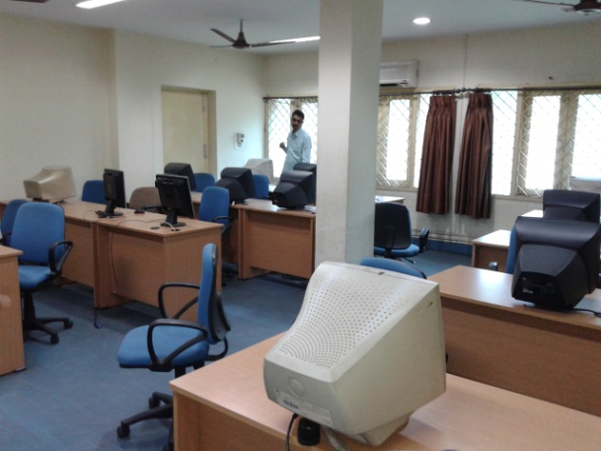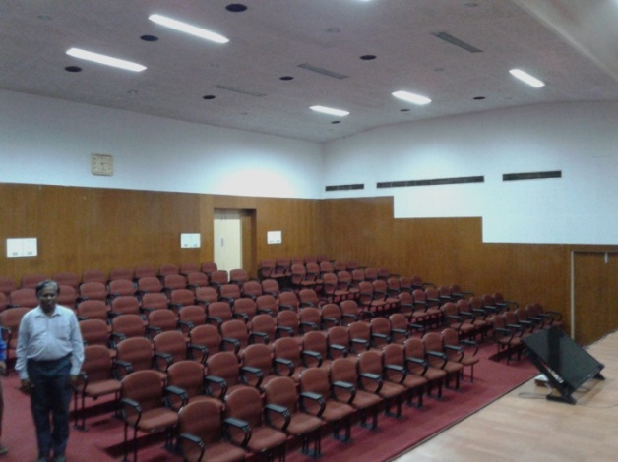

**Auditorium, IIHFW**  **Computer Lab**

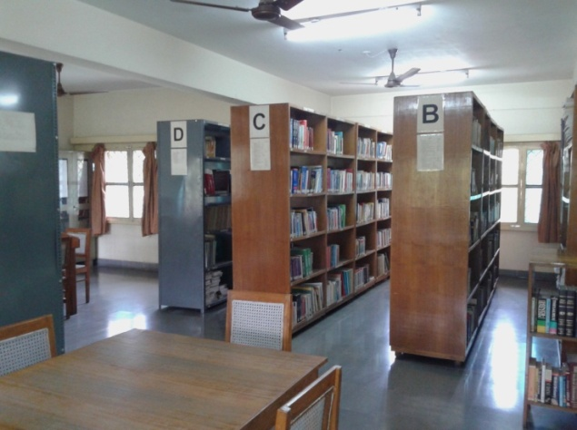

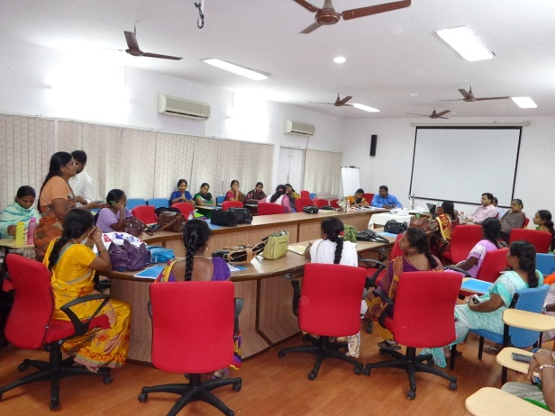

**Lecture/Conference Hall-1** **Library**

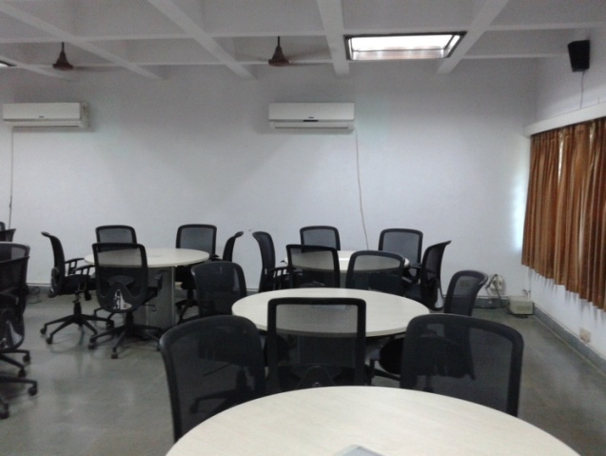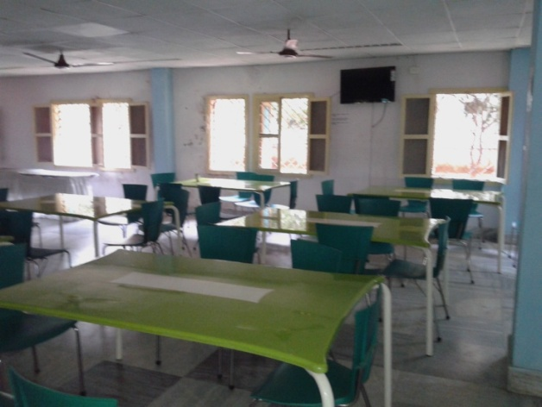

**Hostel Mess/Dining Hall Board Room**

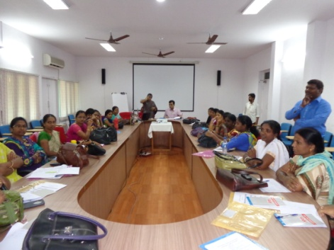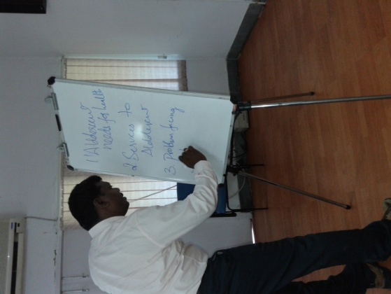

**Training/Conference Hall Display Board**

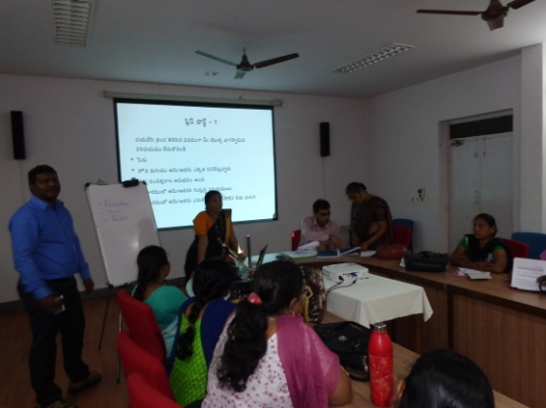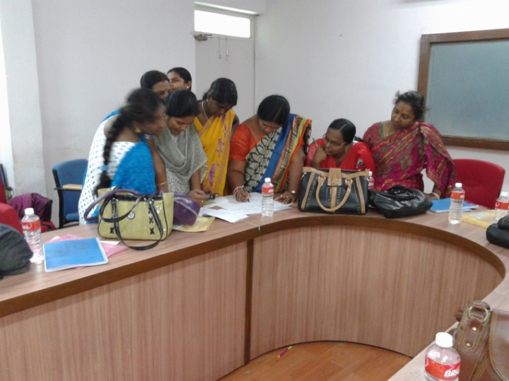

**Training Hall (Group Activity) Training Hall**

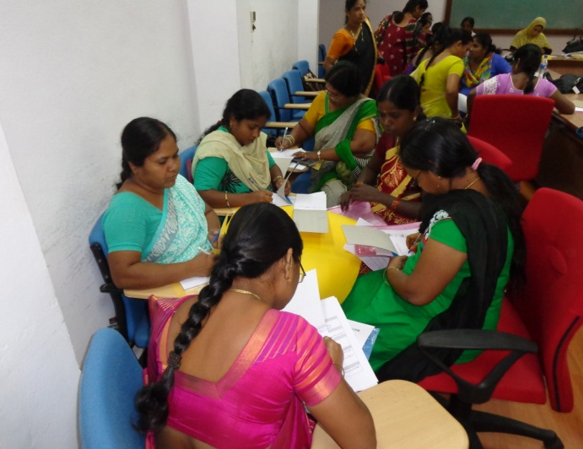

**Group exercise with problem cards**

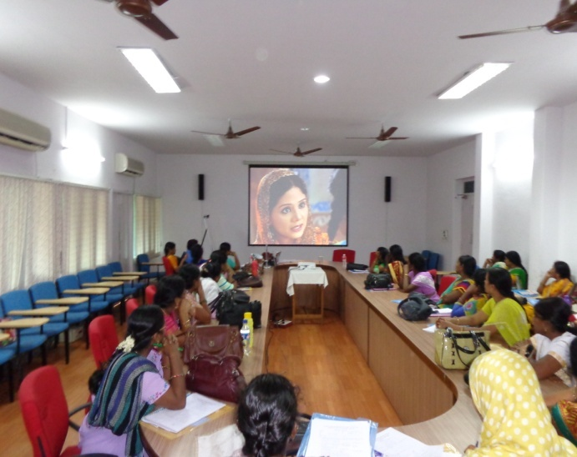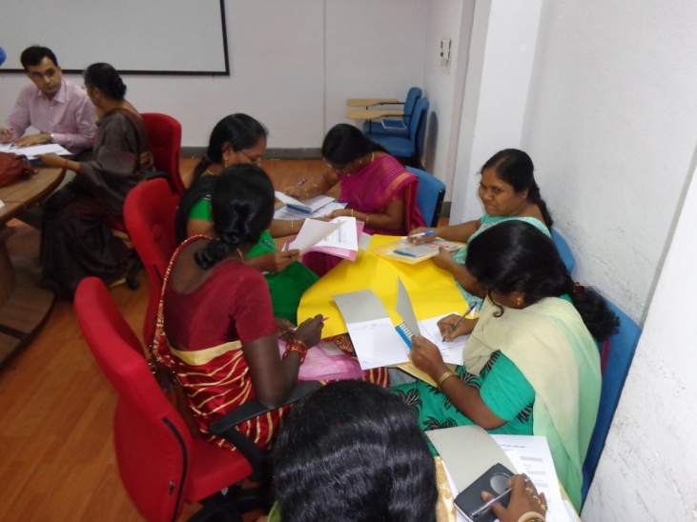

**Brainstorming and Group discussion Video Clip Show**

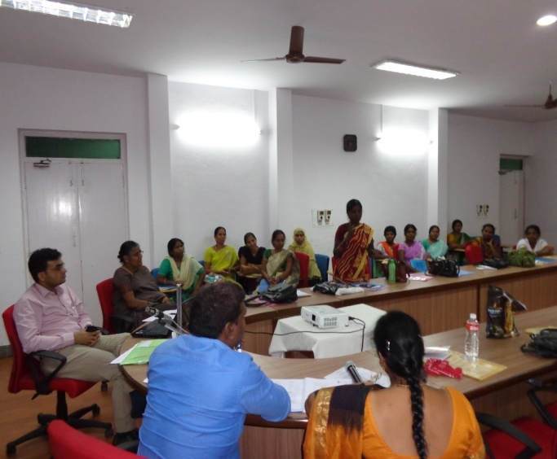

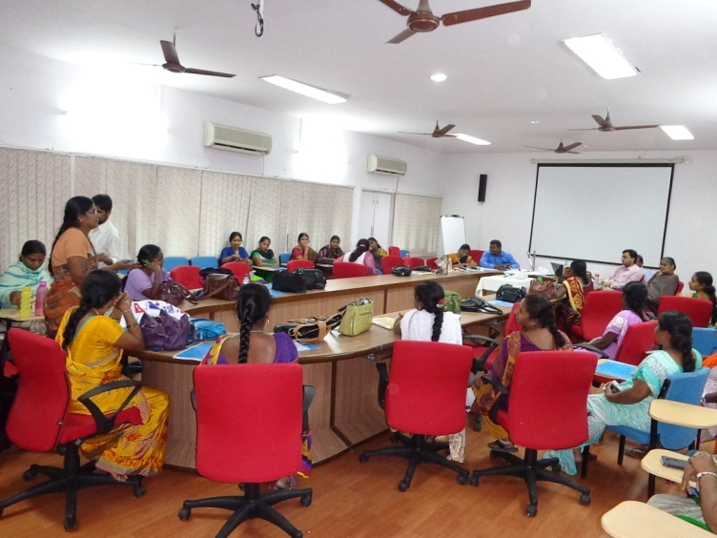 **Self reading of module Role Play**

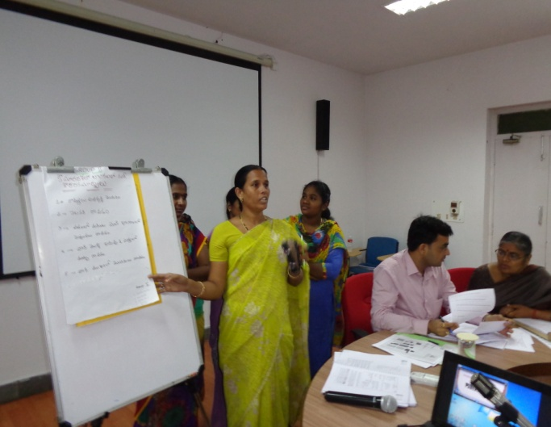

**Flipchart presentation**